Tab 1
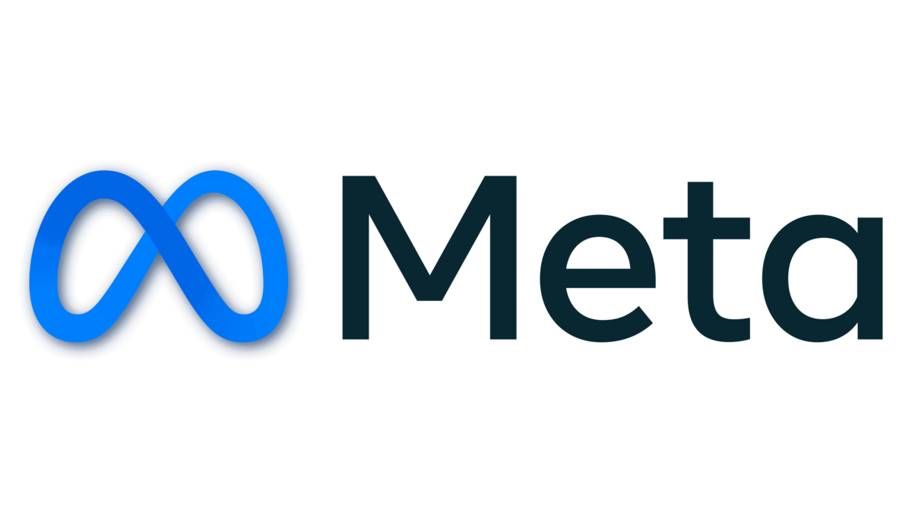

SQL: Social Media Project

Answers of Objective Questions

Q1. Are there any tables with duplicate or missing null values? If so, how would you handle them?

Ans : I generated queries using the GROUP BY clause to group rows based on the target columns that need to be checked for duplicate values. By applying the HAVING COUNT(*) > 1 condition, I was able to identify any entries where the same data appears more than once.
For checking missing or incomplete data, I wrote queries that use the IS NULL condition to find rows where essential columns do not have any value.
After running these queries on all relevant tables, I confirmed that there are no duplicate entries and no NULL values present. This ensures data integrity and supports the reliability of the system.
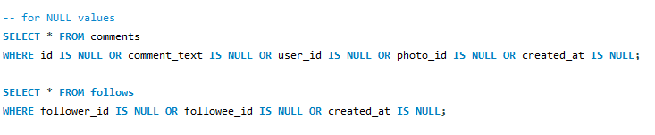
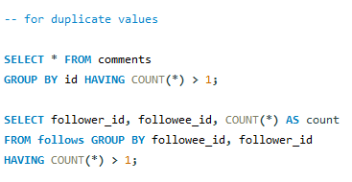
Q2. What is the distribution of user activity levels (e.g., number of posts, likes, comments) across the user base?
Ans : The query generates a summary of user activity for the first 50 users, showing how many posts, likes, and comments each user has contributed. It uses LEFT JOIN to combine data from related tables—photos, likes, and comments—while ensuring that every user is included, even if they haven’t posted, liked, or commented. By counting distinct posts, likes, and comments, the query provides accurate activity metrics for each user. Grouping by user ID and username allows the results to be organized per user, and the LIMIT 50 clause restricts the output to the top 50 users, helping to analyze activity levels efficiently for a sample of the user base.

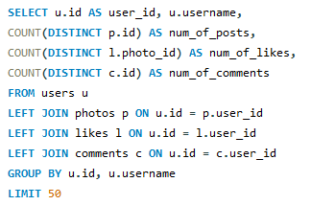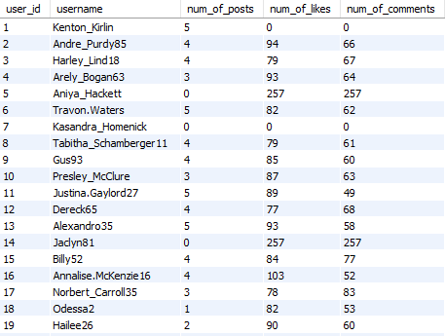

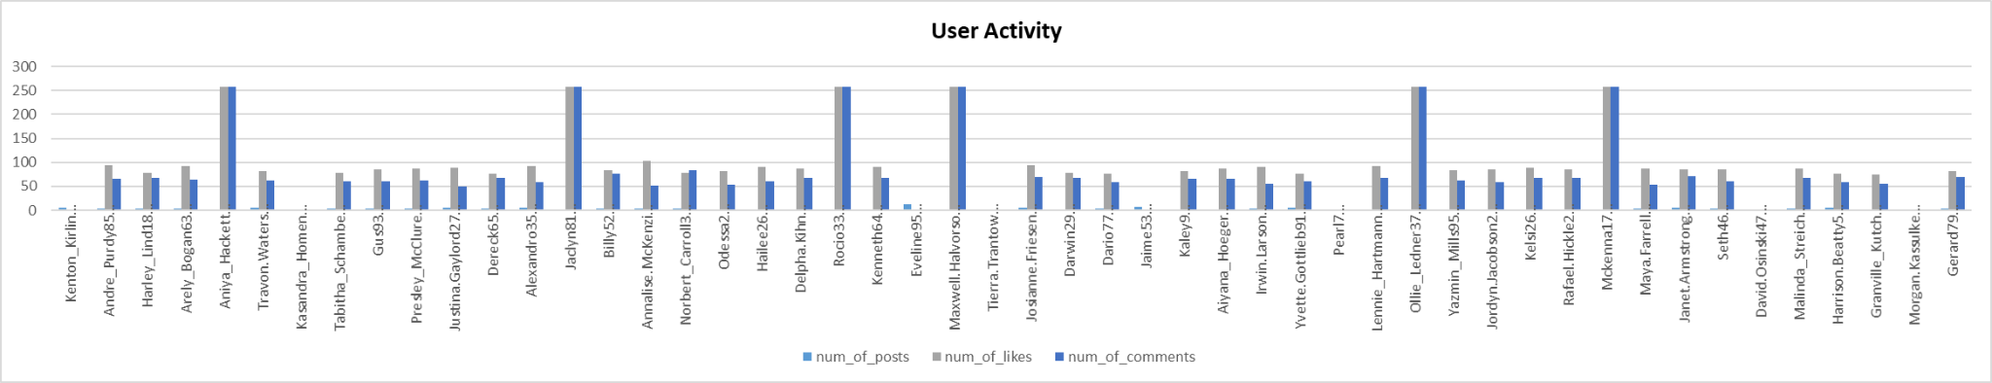

Q3. Calculate the average number of tags per post (photo_tags and photos tables)
Ans : In this query, a Common Table Expression (CTE) is used to create a temporary result set that makes the query easier to read and understand. Within the CTE, the photos and photo_tags tables are joined using a LEFT JOIN so that even posts with zero tags are included in the calculation. The query groups the results by each photo’s ID and counts the total number of tags per post.
Afterward, the main query calculates the average number of tags per post by using the AVG() function on the total tags from the CTE. The result is rounded to the nearest whole number using ROUND(), since tags cannot be fractional. This approach ensures an accurate and complete average by considering all posts, whether they have tags or not.
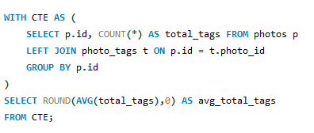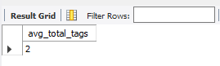

Q4. Identify the top users with the highest engagement rates (likes, comments) on their posts and rank them.
Ans : In this query, I calculated the engagement rates of users by combining their total likes and comments. First, I used two Common Table Expressions (CTEs) – Total_likes and Total_comments – to separately count the likes and comments each user has received. The LEFT JOIN ensures that even users with no likes or comments are included in the results.
After calculating the total likes and comments, the main query sums them up to compute the overall engagement_rate for each user. I used the DENSE_RANK() window function to rank users based on their engagement rate in descending order, meaning users with higher engagement are ranked at the top. Finally, the query limits the output to the top 20 users.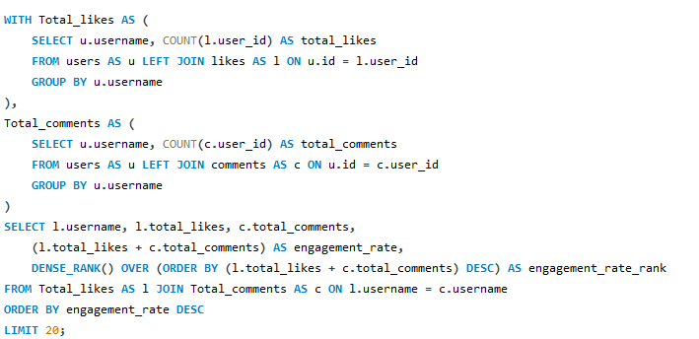
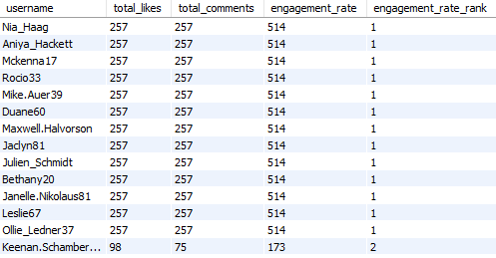

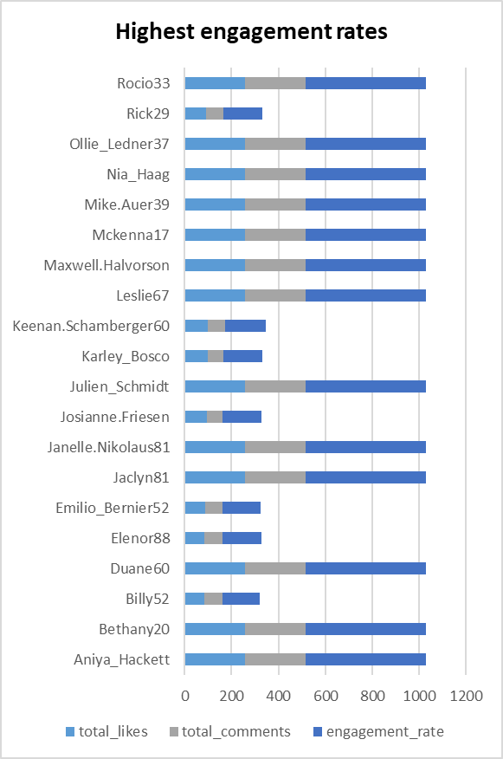

Q5. Which users have the highest number of followers and followings?
Ans : In this query, I calculated the number of followers and followings for each user by using two Common Table Expressions (CTEs). The first CTE, Count_of_followers, counts how many followers each user has by grouping the follows table by followee_id. The second CTE, Count_of_followee, counts how many users each user is following by grouping by follower_id.
In the final query, I joined these CTEs with the users table using LEFT JOIN to ensure that even users with no followers or followings are included in the result. I used COALESCE() to replace any NULL values with 0, which ensures that users without any followers or followings are displayed correctly.
The result provides a complete list of users along with their follower and followee counts, ordered by user ID.

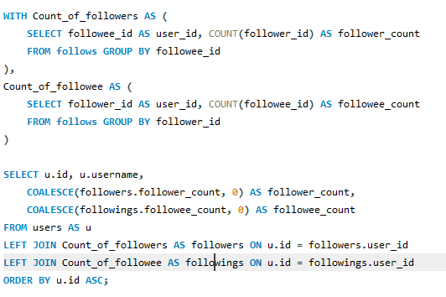

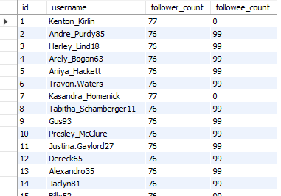

Q6. Calculate the average engagement rate (likes, comments) per post for each user.
Ans : In this query, I calculated the average engagement rate per post for each user by combining likes and comments on their photos. First, using a Common Table Expression (CTE) named engagement, I joined the users, photos, likes, and comments tables to count the total likes and comments for each photo posted by a user. The LEFT JOIN ensures that users with no posts are still considered, while the JOIN on likes and comments helps aggregate interactions on each post.
In the final part of the query, I grouped the data by user ID and username and calculated the average engagement by adding likes and comments for each post. The result is rounded to two decimal places using ROUND(). The query orders the users by the highest average engagement rate in descending order, providing insights into which users receive the most interaction on their posts.
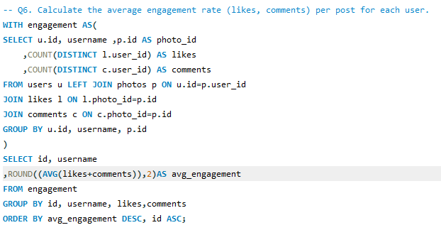
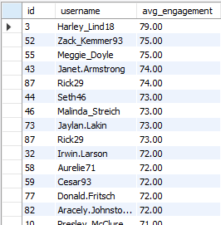

Q7. Get the list of users who have never liked any post (users and likes tables)
Ans : In this query, I retrieved the list of users who have never liked any post by checking the likes table. The NOT IN clause is used to filter out users whose id is present in the user_id column of the likes table. This ensures that only users who have no likes recorded are included in the result.

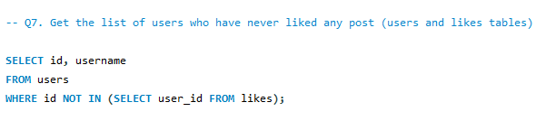
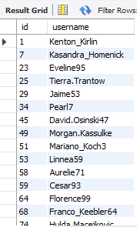

Q8. How can you leverage user-generated content (posts, hashtags, photo tags) to create more personalized and engaging ad campaigns?
Ans : This query identifies the most frequently used tags by analyzing the photo_tags and tags tables. By counting how often each tag is associated with a photo, it provides insights into the topics and themes that users are engaging with the most.
How this helps for personalized ad campaigns:
- By identifying the most popular tags, marketers can create targeted ads around trending topics and interests.
- Ads can be customized based on user preferences, making them more relevant and likely to engage users.
- Understanding tag usage helps in designing content strategies, hashtags, and campaigns that resonate with the audience's interests.
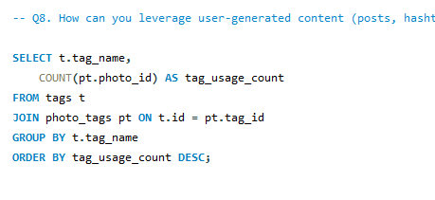
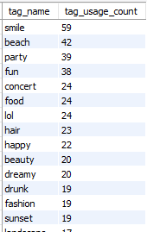
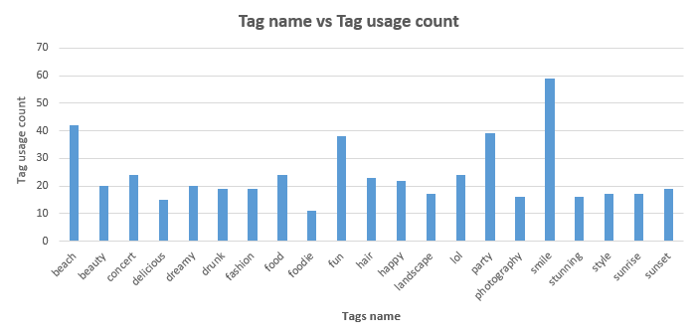

Q9. Are there any correlations between user activity levels and specific content types (e.g., photos, videos, reels)? How can this information guide content creation and curation strategies?
Ans : In this query, I explored the correlation between user activity levels—specifically the number of photo uploads—and the engagement they receive in terms of likes and comments. Using Common Table Expressions (CTEs), I first calculated:
- uploads: the total number of photos uploaded by each user,
- likes: the total likes received by the user's photos,
- comments: the total comments received by the user's photos.
In the final part of the query, I grouped users based on their photo uploads and calculated the average engagement (likes plus comments) for each group. The OVER(PARTITION BY photo_uploads) clause helps understand how engagement varies across users with different levels of activity.
Insights and strategy implications:
- If users who upload more photos consistently receive higher engagement, content creators and platforms can encourage frequent posting by providing incentives or tools that simplify photo uploads.
- For content curation, knowing which activity levels correspond to higher engagement helps target users with personalized recommendations or prompts to post more.
- It also aids in designing campaigns or features tailored to users’ content creation habits, ultimately improving user interaction and platform growth.
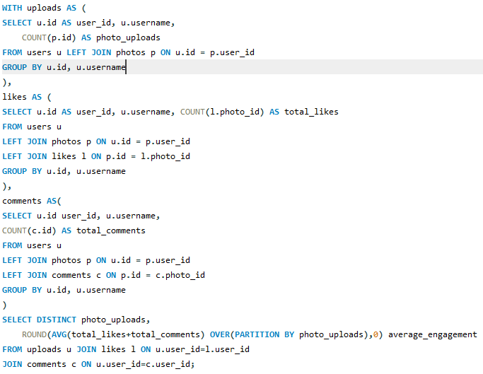
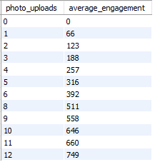
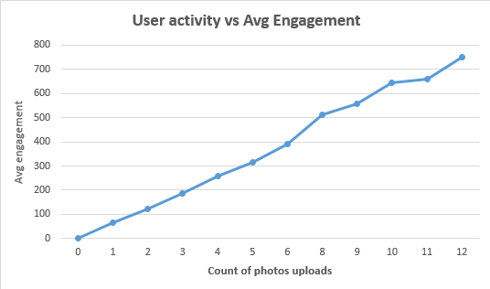

Q10. Calculate the total number of likes, comments, and photo tags for each user.
Ans : In this query, I calculated the total number of likes, comments, and photo tags for each user by using three Common Table Expressions (CTEs):
- likes_count: Counts how many likes each user has given.
- comments_count: Counts how many comments each user has made.
- phototags_count: Counts how many tags are associated with the photos uploaded by each user.
The final query joins these results with the users table using LEFT JOIN to ensure that even users with no activity are included. The COALESCE() function replaces NULL values with 0, so that users without likes, comments, or photo tags are still displayed with zeros.
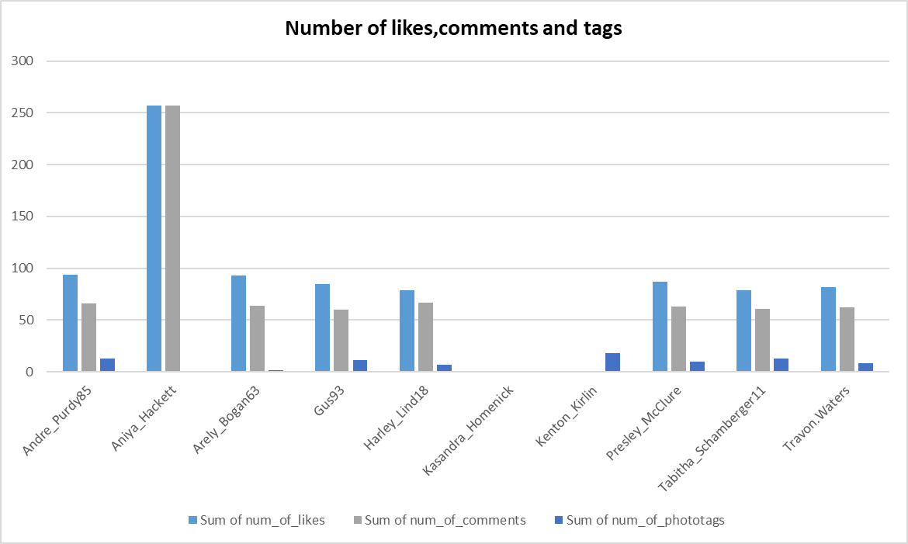
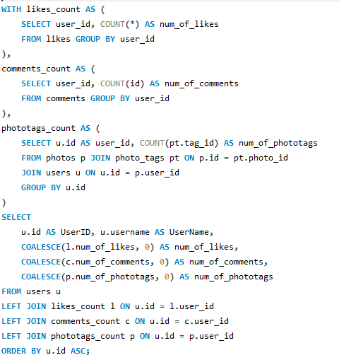

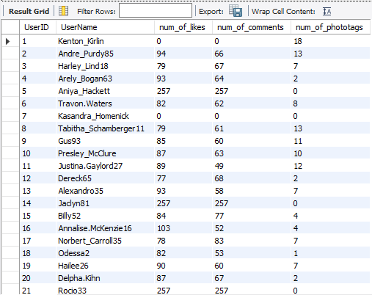

Q11. Rank users based on their total engagement (likes, comments, shares) over a month.
Ans :
- Post_likes CTE: This Common Table Expression (CTE) calculates the total number of likes for each user. It selects the user_id and counts the number of likes, aliasing the count as like_count. The query specifically filters for data from November 2024 using EXTRACT(MONTH FROM created_at) = 11 AND EXTRACT(YEAR FROM created_at) = 2024, then groups the results by user_id.
- Post_comments CTE: Similar to the previous CTE, this one counts the total number of comments for each user. It selects the user_id and counts the number of comments, aliasing the count as comment_count. Like the Post_likes CTE, it also filters for comments made in November 2024.
- Total_likes_n_comments CTE: This CTE is the core of the query. It joins the users table with the two preceding CTEs using LEFT JOIN to ensure all users are included, even those with zero likes or comments. The COALESCE function is crucial here; it replaces any NULL values (from users with no likes or comments) with a 0, preventing errors in calculations. It also creates a new column, total_engagement, by summing the like_count and comment_count for each user.
- Main SELECT Statement: This final statement retrieves the user data. It selects the User_id, Username, like_count, comment_count, and total_engagement from the Total_likes_n_comments CTE. It then uses the DENSE_RANK() window function to assign a rank to each user based on their total_engagement score, ordered in descending order. This means users with the highest engagement will have the lowest rank (e.g., rank 1). The DENSE_RANK() function gives the same rank to users with the same total engagement score, and the next rank is a consecutive number.

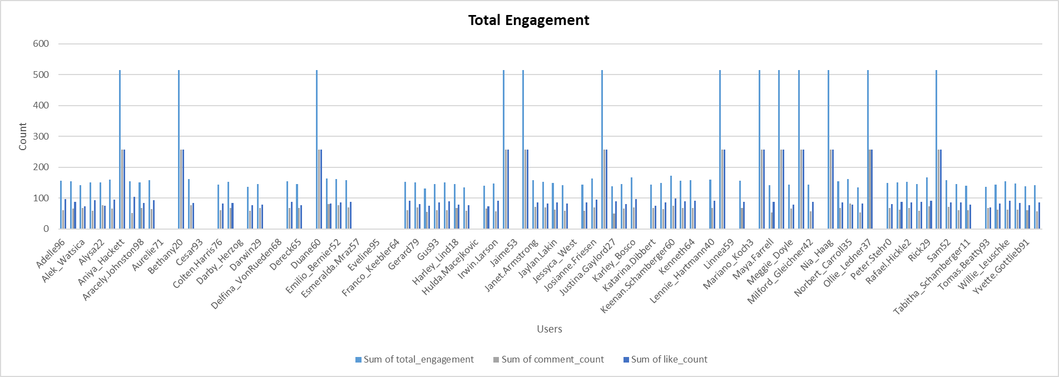

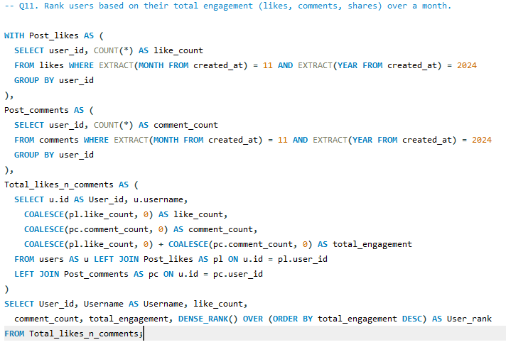

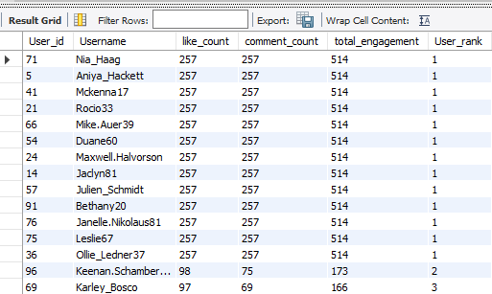

Q12. Retrieve the hashtags that have been used in posts with the highest average number of likes. Use a CTE to calculate the average likes for each hashtag first.
Ans :
- The Likes_Count CTE: This CTE, or Common Table Expression, is used to count the number of likes for each photo. It groups all entries in the likes table by photo_id and uses COUNT(user_id) to get the total number of likes, which is aliased as LikesCount.
- Joining the Tables: The main query starts by joining the tags table with the photo_tags table. This link is established on t.id = pt.tag_id, which correctly associates each hashtag with the photos it has been used on.
- Integrating the CTE: Next, the query performs another join, this time connecting the photo_tags table to the Likes_Count CTE. This step uses pt.photo_id = c.photo_id to link the like counts from the CTE back to the specific hashtags.
- Calculating and Rounding the Average: For each distinct hashtag, the query calculates the average number of likes. It uses the AVG function on the LikesCount column. The ROUND(..., 0) function then rounds this average to the nearest whole number and names it Avg_likes.
- Grouping and Ordering the Results: The query uses GROUP BY t.tag_name to ensure that the average is calculated for each unique hashtag. Finally, the results are sorted in descending order by Avg_likes with ORDER BY Avg_likes DESC, effectively ranking the hashtags from most-liked on average to least-liked.

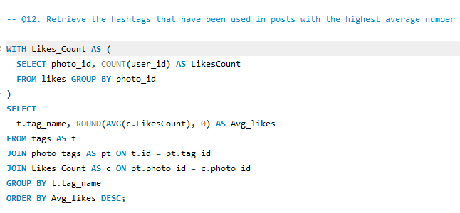
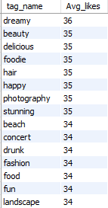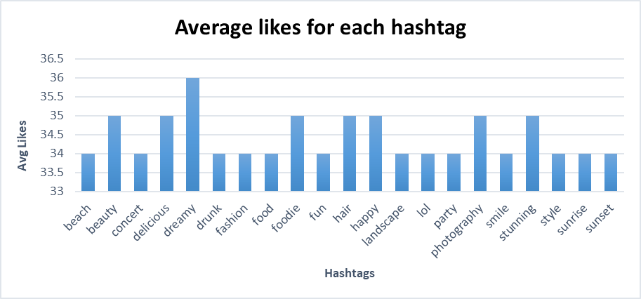
Q13. Retrieve the users who have started following someone after being followed by that person
Ans :
- Self-Join: The query uses a self-join, which means it joins the follows table to itself. This is a powerful technique for comparing rows within the same table. Here, the follows table is aliased as f1 and f2 to distinguish between the two instances.
- Matching Users: The first two ON conditions, f1.follower_id = f2.followee_id and f1.followee_id = f2.follower_id, identify pairs of users who follow each other.
- Temporal Condition: The third ON condition, f1.created_at > f2.created_at, is the key to solving the task. It filters the results to only include cases where the follow action in f1 happened after the follow action in f2.

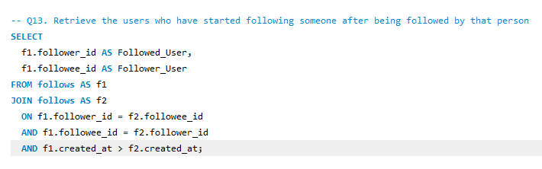

Answers of Subjective Questions

Q1. Based on user engagement and activity levels, which users would you consider the most loyal or valuable? How would you reward or incentivize these users?

Ans : Common Table Expressions (CTEs) to first isolate and count specific user activities:
- likes_count: Tallies the total likes a user has given.
- comments_count: Counts how many comments a user has made.
- photo_counts: Records the number of photos a user has uploaded.
- phototags_count: Counts how many times a user's photos have been tagged.
- followers_count and followees_count: Measures a user's social influence by counting their followers and who they are following.
By joining these metrics and using COALESCE to replace any missing counts with zero, the query creates a complete profile for each user. It then calculates an engagement_rate by summing likes, comments, and photos—three core actions that contribute directly to a platform's vitality. Finally, the DENSE_RANK() function sorts users by this engagement score, with the highest-ranked users being the most valuable.

How to Reward and Incentivize These Users
Once you've identified your most valuable users, you can reward them with a tiered incentive program to encourage continued loyalty and engagement.
- Exclusive Recognition and Status: Grant these users special badges or custom titles that set them apart from the community. You could also feature them in a "User Spotlight" or "Top Contributors" section on the platform's homepage or social media channels. This public recognition gives them a sense of status and appreciation.
- Tangible Rewards: Offer material incentives like platform-branded merchandise, premium subscriptions, or gift cards to popular services. These rewards show your gratitude in a concrete way and encourage repeat engagement.
- First Access to New Features: Give them early access to new tools, features, or content. This not only makes them feel valued as insiders but also allows them to provide crucial feedback before a wider launch. Their high engagement rate means they are more likely to test and promote these features organically, benefiting the company as well.
- Invitation-only Events: Organize exclusive online or in-person events where top users can network with each other and with platform staff. This builds a strong sense of community and provides a unique experience that reinforces their bond with the platform.

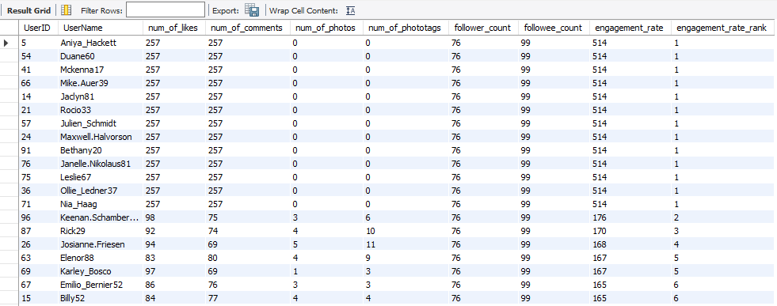

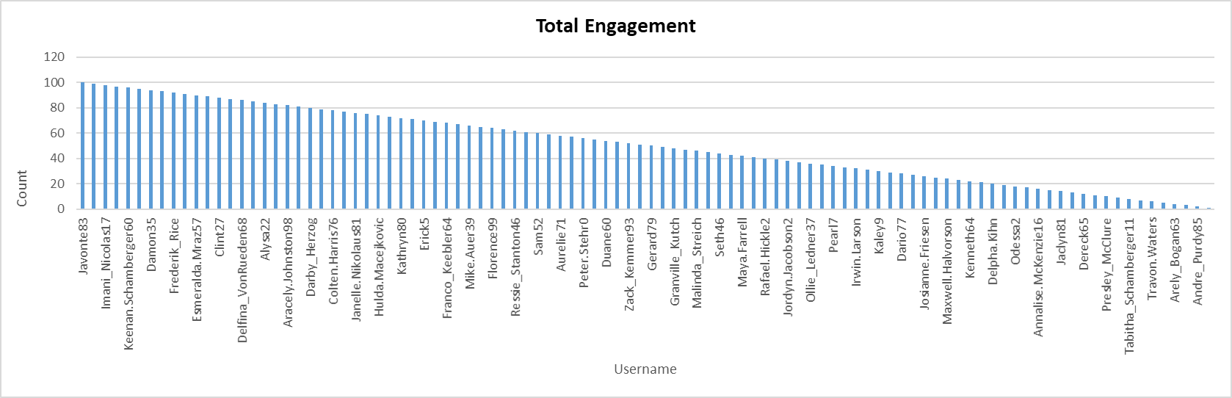

Q2. For inactive users, what strategies would you recommend to re-engage them and encourage them to start posting or engaging again?

Ans : CTEs Count Specific Activities: The query first uses several Common Table Expressions (CTEs) to count specific user actions:
  - likes_count: The number of likes by each user.
  - comments_count: The number of comments by each user.
  - photo_counts: The number of photos uploaded by each user.
  - phototags_count: The number of times a user's photos have been tagged.
  - Count_of_followers: The number of followers each user has.
- Data Consolidation: The main query uses a series of LEFT JOIN statements to combine these activity counts with the primary users table. This ensures that all users are included, even those who haven't performed a specific action.
- Handling Missing Data: The COALESCE function is used to replace any missing (NULL) values from the joins with a 0, which prevents errors and ensures accurate calculations.
- Calculating Engagement: An engagement_rate is calculated by adding a user's total likes, comments, and photos. This metric represents their overall level of activity.
- Ranking Users: The DENSE_RANK() window function assigns a rank to each user based on their engagement_rate, ordered in descending order. This means users with the highest engagement are ranked first.
- Identifying Value: The resulting ranking allows you to identify your most loyal and valuable users—those who consistently engage with the platform and its content.

Strategies to Re-engage Inactive Users
Re-engaging inactive users requires a targeted approach that addresses their specific reasons for leaving. Here are several strategies you could recommend:
- Personalized E-mail Campaigns: Send automated e-mails to inactive users that are tailored to their past behavior. Showcase popular content or posts from their network they might have missed. You can also send them curated suggestions for groups, hashtags, or users they might find interesting based on their old activity logs.
- Contests and Challenges: Introduce short-term contests or challenges with clear rules and exciting prizes. These can be as simple as a "Photo of the Week" contest or a creative challenge. The goal is to lower the barrier to participation and give them a compelling reason to log back in and engage.
- Incentives and Rewards: Offer a reward for a simple action. A limited-time offer, a discount code, or even a small amount of in-app currency can motivate them to return. These incentives don't need to be huge; they just need to signal that you value their return.
- Streamlined User Experience: Simplify the content creation process. For instance, offer them templates or prompts that make it easier for them to start posting again. This reduces the mental effort required and can make it less intimidating to get back on the platform.
- Feedback Surveys: Send a brief, easy-to-complete survey to ask for feedback on why they've been inactive. This not only gives you direct, actionable insights but also shows users that their opinion matters. You can then use this data to make meaningful changes to the platform.

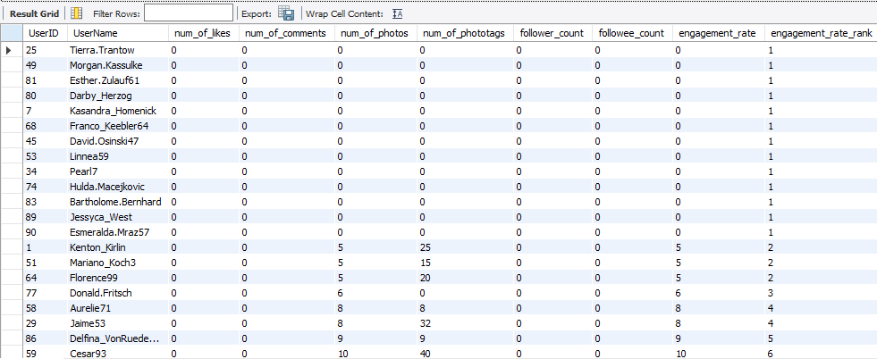
This chart displays the user with the highest level of inactivity, ranked number one among inactive users.

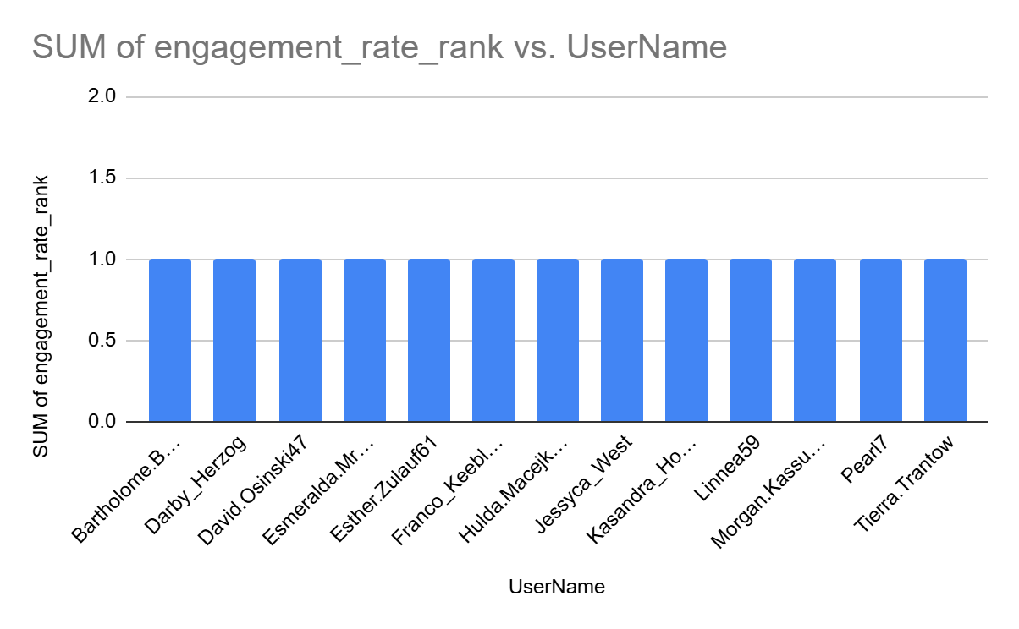

Q3. Which hashtags or content topics have the highest engagement rates? How can this information guide content strategy and ad campaigns?

Ans : The query begins by creating two Common Table Expressions (CTEs), Likes and Comments, to count the total likes and comments associated with each photo_id.
- It then joins the tags table with the photo_tags table to link each hashtag to its corresponding photos. A LEFT JOIN with the Likes and Comments CTEs is then performed to pull in the total like and comment counts for each photo.
- For each unique hashtag, the query calculates the total number of associated posts, along with the total likes and total comments.
- The engagement rate is then calculated by taking the average sum of likes and comments per post for each hashtag.
- Finally, the results are ordered by this engagement rate in descending order, with the top 10 most engaging hashtags displayed. This helps identify the most effective hashtags for content and ad strategies.

Strategies for High-Engagement Hashtags
Leveraging these high-engagement hashtags can significantly boost your content's reach and effectiveness.
- Prioritize Content Topics: Create more posts centered around the high-engagement hashtags. This strategy helps attract a larger audience and keeps existing followers interested in your content.
- Targeted Ad Campaigns: Use these top-performing hashtags in your ad campaigns. Ads related to popular topics are more likely to resonate with the target audience, leading to better performance and higher conversion rates.
- Refine Hashtag Strategy: Boost organic reach by using these effective hashtags to increase post visibility and discoverability.
- Develop Content Series: Create a recurring content series based on the most popular hashtags. For example, a weekly or monthly post series using a specific hashtag could build anticipation among your followers.
- Influencer Collaborations: Partner with influencers who are experts in these high-engagement topics. A collaboration with a food blogger using a popular hashtag like #foodie can drive relevant traffic and boost your post's credibility.

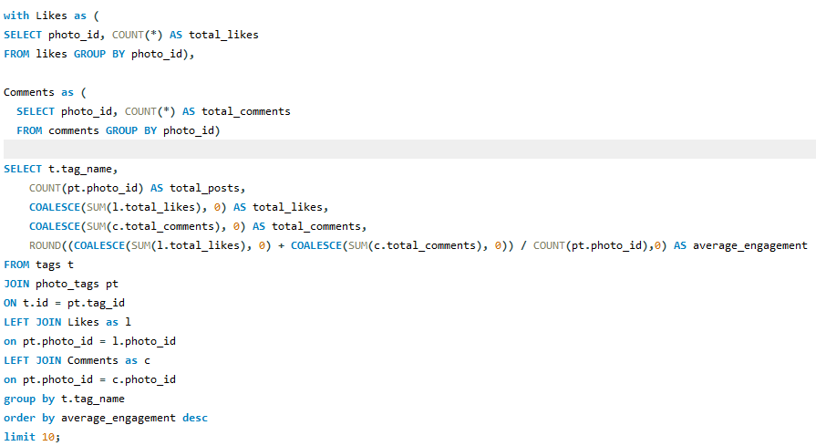

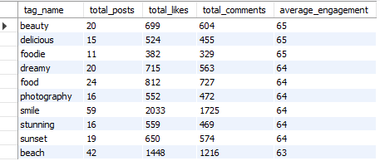

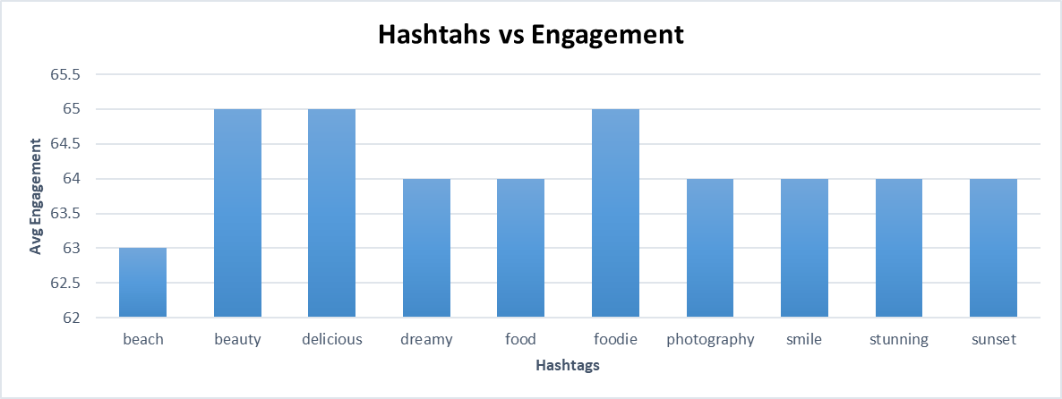

Q4. Are there any patterns or trends in user engagement based on demographics (age, location, gender) or posting times? How can these insights inform targeted marketing campaigns?

Ans : The query calculates engagement based on posts, likes, and comments over time.
- It starts by creating two Common Table Expressions (CTEs), Likes and Comments, to count the total likes and comments for each photo.
- The main query then joins these CTEs with the photos table to combine engagement data with the creation time of each post.
- It extracts the hour and day of the week from the post's creation time to group the data.
- The query calculates the total posts, likes, and comments for each time period, and then divides the sum of likes and comments by the number of posts to determine the average engagement.

Patterns and Strategies
This query can't analyze demographics like age or gender. However, it is an excellent tool for uncovering time-based patterns and trends in user engagement, which are crucial for targeted marketing.
- Identifiable Patterns: The query's output will show which hours and days have the highest Average_engagement. This can reveal that users are most active at specific times, such as late evenings or weekends. This pattern suggests that content posted during these times is more likely to be seen and interacted with.
- Optimal Posting Time: You can use these findings to schedule your social media posts for peak engagement times. This will maximize the visibility of your content and can lead to more likes, comments, and shares.
- Targeted Content: The insights can also inform your content strategy. For example, if nighttime engagement is high, you could create content that is more relatable to that time of day, such as posts about dinner, movies, or late-night thoughts. Using related hashtags like #datenight or #lategram can also help you reach a more engaged audience.
- Geographical Targeting: While not directly shown in the query, posting times often correlate with time zones. You can tailor your posting schedule for different regions to match their peak activity hours.
- Ad Campaigns: For paid marketing, these insights allow you to schedule your ads to run when your target audience is most active, which can significantly improve ad performance and lead to higher conversion rates.
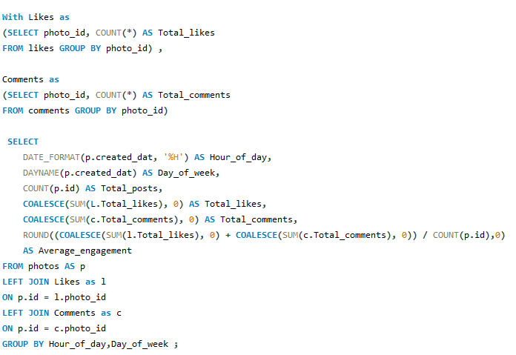

Q5. Based on follower counts and engagement rates, which users would be ideal candidates for influencer marketing campaigns? How would you approach and collaborate with these influencers?

Ans : Why these users are ideal for influencer marketing:
- High Engagement: Users with more interactions (likes and comments) on their content are more likely to have an active and loyal audience.
- Strong Reach: A higher number of followers means their content reaches a broader audience, increasing the campaign’s visibility.
- Balanced Influence: The engagement rate ensures that users are not just accumulating followers passively but are actively influencing their community.
Approach for collaborating with these influencers:
Personalized Outreach: Approach each influencer with tailored communication that highlights how their content aligns with the brand’s values and target audience.
- Content Co-Creation: Work collaboratively to create authentic and engaging content that resonates with their followers while promoting products or services.
- Incentive Programs: Offer appropriate compensation, affiliate links, or performance-based rewards to encourage sustained collaboration.
- Track & Optimize: Monitor campaign performance and engagement metrics regularly to optimize strategies and ensure mutual benefit.
This approach ensures that influencer campaigns are data-driven, targeted, and impactful, leveraging users with both reach and audience interaction for maximum marketing effectiveness.
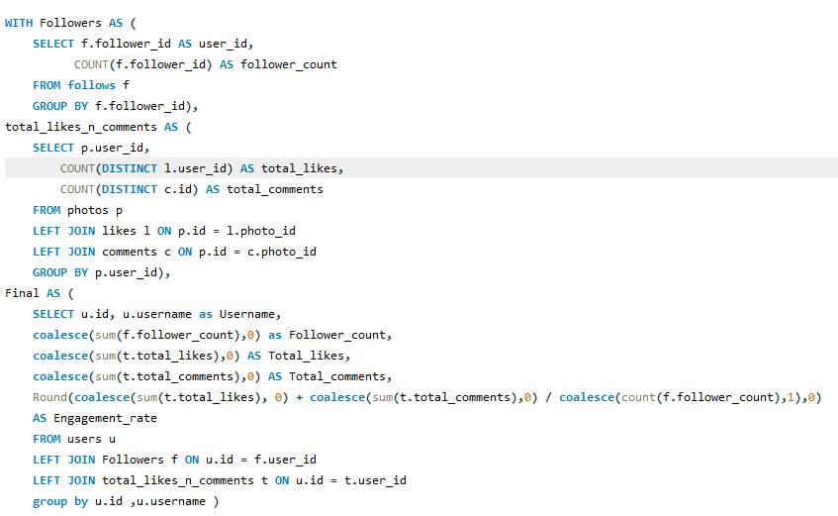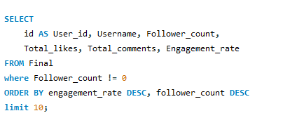

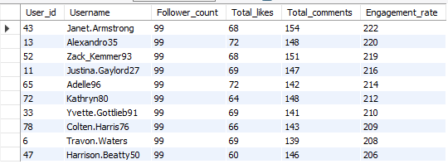

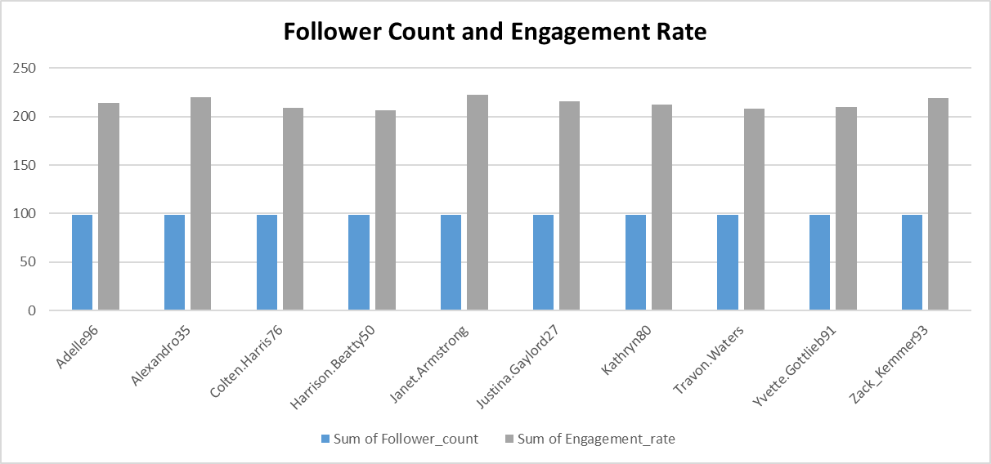

Q6. Based on user behavior and engagement data, how would you segment the user base for targeted marketing campaigns or personalized recommendations?

Ans : This query segments users based on their engagement levels, categorizing them into Active Users, Moderately Active Users, and Inactive Users for targeted marketing campaigns or personalized recommendations.
It first calculates the total likes and comments for each user using the Likes and Comments CTEs. Then, it computes the total number of photos each user has posted.
The Engagement_rate is calculated by dividing the sum of likes and comments by the total number of photos, showing how actively users interact with the platform.
Based on this engagement rate:
- Users with a rate above 150 are considered Active Users,
- Users with a rate between 100 and 150 are Moderately Active Users,
- Users with a lower rate or no posts are Inactive Users.
The query groups users by their ID and username, orders the results by engagement rate in descending order, and prioritizes the most engaged users for marketing efforts.

Targeted Marketing Campaigns and Personalized Recommendations
A) Active Users:
- Marketing Campaigns:
Offer exclusive discounts, early access to new products, or premium content that aligns with their interests. Reward them with incentives like gift vouchers or collaborations.
- Personalized Recommendations:
Suggest products or services similar to their past interactions. Customize notifications and offers based on their activity patterns.
B) Moderately Active Users:
- Marketing Campaigns:
Use targeted ads to encourage more participation. Provide time-limited offers or interactive content that invites engagement.
- Personalized Recommendations:
Suggest complementary products or content while introducing fresh or trending options to increase involvement.
C) Inactive Users:
- Marketing Campaigns:
Focus on re-engagement strategies. Send reminders, discounts, or educational content to rekindle interest. Use personalized messaging to win them back.
- Personalized Recommendations:
Recommend popular or captivating content to spark curiosity. Offer prompts or incentives to encourage them to participate more.

Implementation Steps
- Analyze User Data:
Regularly monitor engagement metrics to identify trends and update segmentation strategies accordingly.
- Create Targeted Messaging:
Design personalized messages and offers that align with the unique preferences and behaviors of each group.
- Conduct Strategy Testing:
Experiment with different campaigns in each segment to identify which approaches yield the best results.
- Track and Optimize:
Continuously track campaign performance and engagement rates, adjusting strategies based on feedback and analytics.

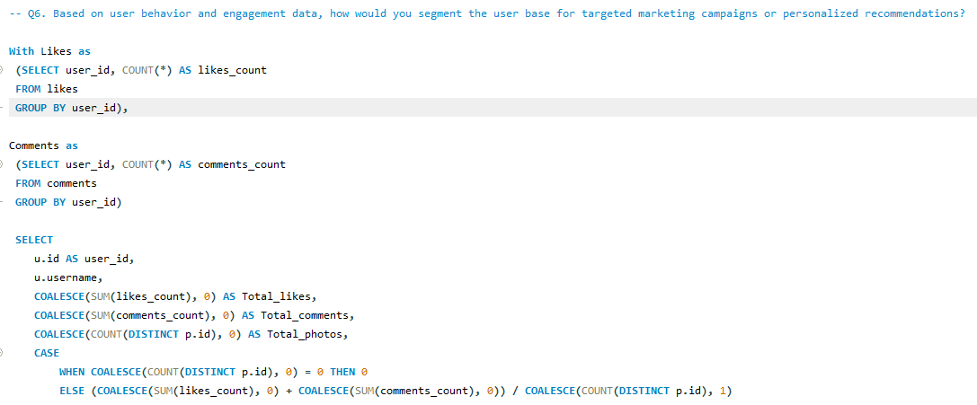
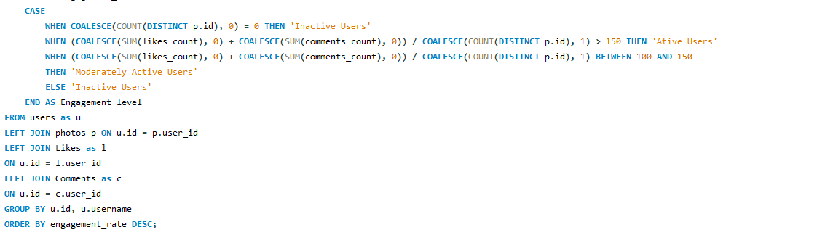

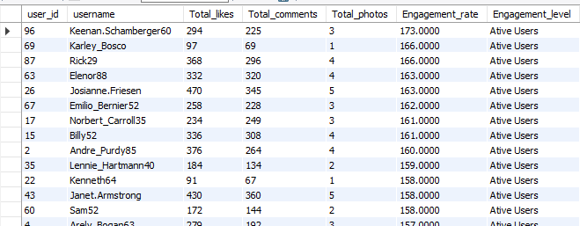

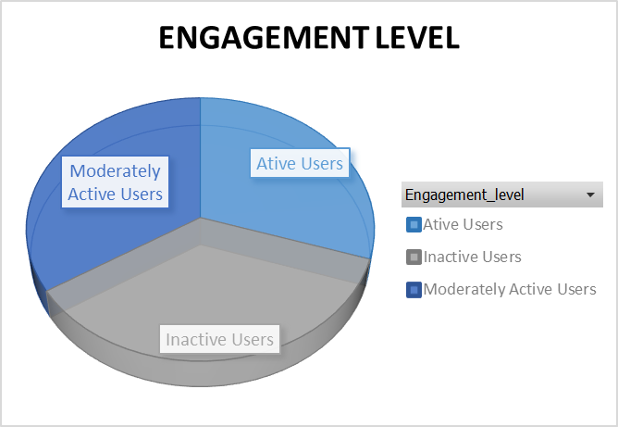

Q7. If data on ad campaigns (impressions, clicks, conversions) is available, how would you measure their effectiveness and optimize future campaigns?

Ans : Analyzing Ad Campaign Performance and Optimizing for Future Success
Analyzing multiple performance indicators that reflect how effectively an ad campaign reaches and engages its target audience is essential for determining its success. Beyond simply measuring effectiveness, the ultimate goal is to leverage this data to enhance future campaigns, resulting in improved engagement, conversions, and return on investment.

Measuring Campaign Effectiveness
- Impressions:
A high number of impressions signals that the ad is visible to a wide audience. However, impressions alone do not provide a full picture of effectiveness. They must be evaluated in conjunction with other key metrics like conversions and clicks.
- Clicks:
A high click-through rate (CTR) indicates that the ad’s design, message, and targeting are resonating with the intended audience. Conversely, a low CTR could suggest issues such as misaligned targeting or uninspiring content.
- Conversion Rate:
A strong conversion rate shows that users are motivated to take desired actions after engaging with the ad. If the rate is low, it may point to issues with the offer, the landing page experience, or other user journey barriers.
- Engagement Metrics:
Even if engagement doesn’t immediately lead to conversions, high interaction rates highlight that the audience finds the content compelling, helping build brand awareness and trust over time.

Optimizing Future Campaigns
- Ad Testing:
Experiment with different versions of ads—changing headlines, visuals, and calls to action—to see which performs best. Use these insights to refine and scale the most successful variants.
- Ad Optimization:
Refresh ad creatives periodically to avoid fatigue and sustain audience interest. Analyze top-performing ads to inform future messaging and design strategies.
- Refining Targeting:
Dive into audience data such as age, gender, location, and interests to identify high-performing segments. Adjust targeting to focus on these groups and allocate more budget where the conversion potential is strongest.
- Landing Page Optimization:
Use user behavior tools like heatmaps and session recordings to continually enhance landing pages. Ensure the content aligns with the ad’s message to improve relevance and conversion rates.
- Utilizing Retargeting:
Serve ads to users who have previously interacted with your brand but haven’t completed a conversion. Retargeting campaigns with personalized messages can help guide users toward completing their desired actions.
- Continuous Monitoring and Iteration:
Regularly track campaign metrics and be agile in making adjustments. If performance declines, be prepared to tweak budgets, targeting parameters, or creative assets in real-time.
- Budget Allocation:
Plan and allocate the budget strategically across campaigns, influencer partnerships, and creative assets. Reallocate funds based on performance data to maximize reach and campaign success.

Conclusion
By systematically analyzing performance metrics and applying data-driven strategies, we can enhance ad effectiveness, foster deeper engagement, and improve conversion rates. This structured approach ensures that future campaigns are better targeted, more relevant, and optimized for maximum impact, helping brands achieve sustained growth and a higher return on investment.

Q8. How can you use user activity data to identify potential brand ambassadors or advocates who could help promote Instagram's initiatives or events?

Ans : We have segmented users into Highly Engaged, Moderately Engaged, and Less Engaged categories. Our next step is to identify those users who are not only highly engaged but also have a strong follower base and actively contribute content. These users can be prioritized as potential brand ambassadors or advocates. Below is how we can strategically use user activity data to make informed decisions:

Identify Highly Engaged Users
- Track users who consistently interact with the brand’s content through likes, comments, shares, and story engagement. These behaviors indicate genuine interest and involvement.
- Spot users who frequently share branded content or mention the brand in their posts and stories. Their willingness to amplify the brand’s message reflects strong advocacy.

Analyze Influence and Reach
- Focus on users with a substantial number of followers, as they have the ability to reach broader audiences. Although follower count alone isn't enough, it serves as a good starting point.
- Identify users who are influencers within relevant niches aligned with the brand’s mission. Such influencers can effectively advocate for brand campaigns or events.

Monitor Content Quality and Brand Alignment
- Review the user’s posted content to see if it reflects the brand’s values and image. For example, users posting about health and wellness would be ideal for fitness-related campaigns.
- Look for users who demonstrate creativity and originality in their content. High-quality visuals and storytelling can enhance brand perception when shared.

Track Loyalty and Consistent Engagement
- Identify users who have been interacting with the brand over an extended period. Consistent engagement is a sign of loyalty and deeper brand connection.
- Prioritize users who have supported the brand in the past without expecting rewards. Their organic advocacy builds trust and credibility.

Evaluate Authentic Advocacy
- Assess whether the user’s interactions feel genuine rather than incentive-driven (such as participation only for giveaways).
- Analyze user-generated content where they share personal experiences with the brand’s products or services. Authentic testimonials reflect stronger brand affinity and trustworthiness.

Reach Out and Build Relationships
- Engage with these users through thoughtful comments, likes, or direct messages to build rapport and understand their willingness to collaborate.
- Offer them opportunities like exclusive events, product launches, or beta testing programs. Providing such experiences not only strengthens the relationship but also allows them to promote the brand in a natural and authentic way.
By systematically identifying, analyzing, and engaging highly active users, we can create a community of passionate brand advocates. These users not only boost visibility but also enhance trust and long-term customer relationships through authentic engagement. This approach helps transform everyday users into powerful ambassadors who genuinely connect with the brand's mission and values.

Q9. How would you approach this problem, if the objective and subjective questions weren't given?

Ans : Certainly, the Objective and Subjective questions were extremely helpful, as they provided a structured outline and enhanced my understanding of the problem, guiding me toward appropriate solutions. However, if these questions had not been provided, I would have adopted a systematic approach with defined steps to analyze the data and derive meaningful insights.

Approach and Steps
1. Problem Identification:
I would begin by clearly defining the goals and expected outcomes of the analysis, whether it’s optimizing user engagement, improving retention, or identifying potential influencers. Based on this understanding, I would develop a structured plan outlining how to process and manipulate the data to achieve the desired insights.
2. Understanding the Data:
Understanding the available data is critical. In this scenario, the dataset is limited to information from 100 users, which would be taken into account when performing deeper analyses and forming conclusions.
3. Data Cleaning and Validation:
My first step would be to examine the data for null values and duplicates across all tables. Any inconsistencies or missing data would be corrected to ensure the dataset is clean and reliable before proceeding with further analysis.
4. Identifying Key Metrics:
- Engagement Metrics:
I would calculate user engagement by analyzing likes, comments, tags, and posts. Additionally, follower and following counts would be reviewed to identify rising influencers and creators.
- Retention Metrics:
I would focus on identifying active users who consistently engage with content over weekly, monthly, and yearly periods. Understanding inactive users’ behavior would also help in designing campaigns to re-engage them by addressing their preferences and needs.
- Acquisition Metrics:
I would analyze user growth patterns, particularly how highly engaged users influence the acquisition of new users and contribute to community expansion.
5. Trend Formation:
Based on observed patterns and business goals, I would develop hypotheses such as, “Users with higher engagement are more likely to stay active over time.” I would then analyze follower activities and other behavioral patterns to validate or refine these hypotheses.
6. Analyzing Trends and Their Influence:
By studying trends like frequently used hashtags, most liked hashtags, and content preferences, I would gain insights into the topics that users are passionate about. This information would be instrumental in identifying influencers for specific topics and creating targeted campaigns.
7. Data-Driven Solutions:
Next, I would use SQL operations to verify the validity of my observations. If discrepancies arise, I would further analyze trends to understand differences and adapt the strategy accordingly.
8. Insights into the Current Scenario:
All outputs from the SQL analysis would be compiled into a comprehensive report outlining the present situation. The report would highlight areas where the organization needs improvement and offer actionable recommendations for boosting engagement and retention.
9. User Segmentation and Targeted Marketing:
- Segment by Engagement Level:
I would classify users based on activity levels (e.g., highly active, moderately active, inactive), and identify users with a high follower count and engagement rate as candidates for brand ambassador roles.
- Personalized Content:
Segmentation would be used to deliver tailored content to different user groups. For instance, inactive users could be targeted with re-engagement campaigns such as email reminders or push notifications.
10. Reporting:
Finally, I would create a detailed report documenting the analysis process, methods used, and key findings. The report would include recommendations for improving user retention, especially among inactive users, and suggest strategic actions for growth. A visually appealing dashboard would be created to present the data clearly and effectively to stakeholders.

Q10. Assuming there's a "User_Interactions" table tracking user engagements, how can you update the "Engagement_Type" column to change all instances of "Like" to "Heart" to align with Instagram's terminology?

Ans : For this problem first I created a new Table User_Interactions with the following Query.
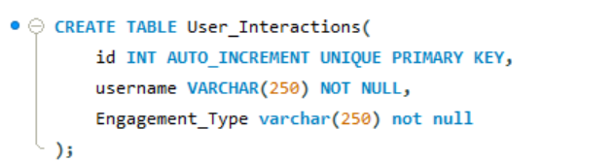

After creating the User_Interaction table then I entered values in the table taking from the original table data.
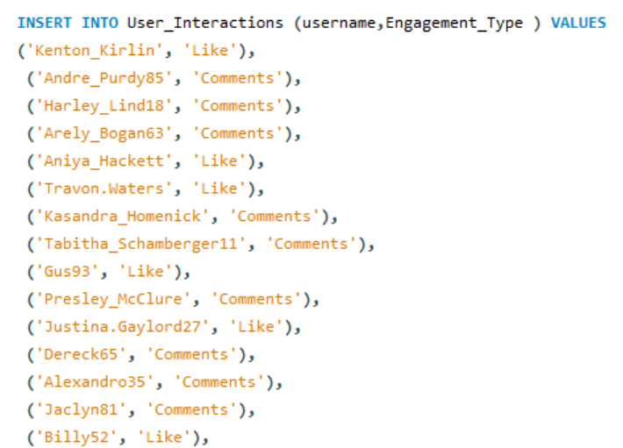

Finally for updating the values in the table User_Interaction which was the original problem statement I constructed the following SQL Query

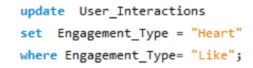

From the above query I got the desired output updating the "Engagement_Type" column to change all instances of "Like" to "Heart" to align with Instagram's terminology.

